# General instruction for preparing the output files

The results of the model are divided into two parts: both can be turned on and off.

1. One part of the result is displayed in charts, which is specified in the Charts.rgg. For simplicity, this part mainly uses for visualization for one plant. The plant number is defined by the variable INDI_ID_A which can be changed in the excel of ‘model input data list.xlsx’. A description of each chart is provided in Charts.rgg. The choice of which charts to display can be specified in the array of CHARTS.
2. Charts can be exported to certain location using the following command: **DATASETS[i].**export(new FileWriter(OUTPUT_LIGHT_TREATMENT + "Output.chart." + i + ".csv"), ",");
3. The location for exporting (PATH_OUTPUT) was defined in the globalParameters.rgg.

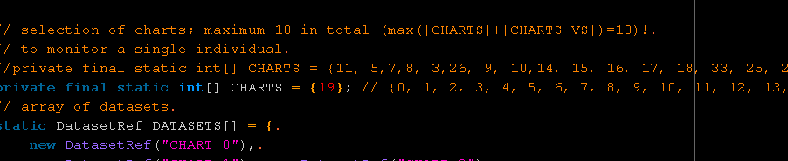

1. The second part of the result is displayed in OutputTables.rgg. There is lots of variables for output, ~400. Table 0 is for plant-level output, table 1 is for organ-level output, table 2 is for field-level output, table 3 is for optimization of transpiration, and table 4 is for optimization of carbon allocation. One can define whatever he wants to export, either for each leaf or whole plant or whole field. The choice of which output tables to update can be specified in the array of TABLES. 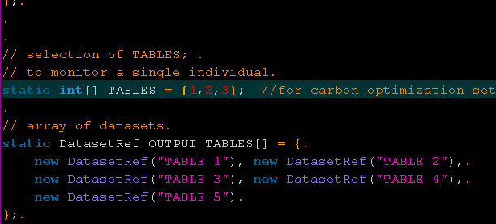
2. Tables can be exported to certain location using the following command: **OUTPUT_TABLES**[0].export(new FileWriter(OUTPUT_CARBON_OPTIMIZATION + "Carbon.allocation.likelihood.2016.7.8" + ".csv"), ",");
3. Because the output table was very large, thus there is a corresponding excel and R code for making it easier to create so many output columns. “Heads of the output table.xlsx” and ‘model output table heads creation.r’. one should probably have a check on the table now. Most of it is up to date, but maybe few columns were changed due to some quick changes in the code directly. Try to keep a good habit in updating the table as well.